Fsd2 unit 3

1)
AIM
write a React program to implement a counter button using React use state hook.
Description:
This React program demonstrates how to use the useState hook to create a functional component with a counter. The counter starts at zero and increments by one each time the user clicks the button.
Program code:-
import React, { useState } from 'react';

function Counter() {
const [count, setCount] = useState(0);
const handleIncrement = () => {
setCount(count + 1);
};
return (
<div style={{ textAlign: 'center', marginTop: '50px' }}>
<h2>React Counter using useState</h2>
<p style={{ fontSize: '24px' }}>Count: {count}</p>
<button onClick={handleIncrement} style={{ fontSize: '16px', padding: '10px 20px' }}>
Increment
</button>
</div>
);
}

export default Counter;
Output:-


2)
AIM:-
write a React program to fetch data from api using React use effect hook
Description:-
This React program uses the useEffect hook to perform a side effect—fetching data from an external API—when the component first mounts. The fetched user data is stored in state using useState, and then rendered in a list.

Program code:-
import React, { useState, useEffect } from 'react';

function UsersList() {
const [users, setUsers] = useState([]);

// Fetch data from API on component mount
useEffect(() => {
fetch('https://jsonplaceholder.typicode.com/users') // sample public API
.then(response => response.json())
.then(data => setUsers(data))
.catch(error => console.error('Error fetching data:', error));
}, []); // Empty dependency array → runs only once after initial render

return (
<div style={{ padding: '20px' }}>
<h2>User List (Fetched using useEffect)</h2>
<ul>
{users.map(user => (
<li key={user.id}>
<strong>{user.name}</strong> - {user.email}
</li>
))}
</ul>
</div>
);
}

export default UsersList;
Output:-
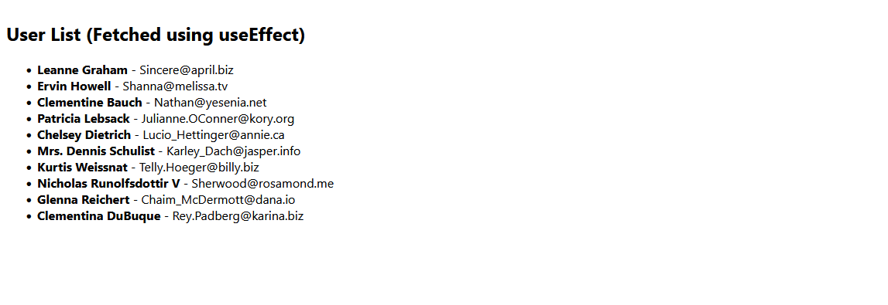
3)
Aim:
write a react program with two react component sharing data using props.
Description:
In this program, the App component acts as a parent that holds user data. It passes the data as props to two child components: UserGreeting (which displays a greeting) and UserInfo (which shows user details).

Program code:-
📄 App.js (Parent Component)
import React from 'react';
import UserGreeting from './UserGreeting';
import UserInfo from './UserInfo';
import './App.css';
function App() {
const user = {
name: 'NANDINI',
age: 24
};

return (
<div className="app-container">
<div className="card">
<h2>Sharing Data Using Props</h2>
<UserGreeting name={user.name} />
<UserInfo name={user.name} age={user.age} />
</div>
</div>
);
}
export default App;
📄 UserGreeting.js (Child Component 1)
import React from 'react';
function UserGreeting({ name }) {
return <h3 className="greeting">Hello, {name} 👋</h3>;
}
export default UserGreeting;

📄 UserInfo.js (Child Component 2)
import React from 'react';

function UserInfo({ name, age }) {
return (
<p className="info">
User <strong>{name}</strong> is <strong>{age}</strong> years old.
</p>
);
}

export default UserInfo;

🎨 App.css
body {
margin: 0;
padding: 0;
font-family: 'Segoe UI', sans-serif;
background: linear-gradient(135deg, #74ebd5, #acb6e5);
height: 100vh;
}

.app-container {
display: flex;
justify-content: center;
align-items: center;
height: 100%;
}

.card {
background-color: #ffffffcc;
padding: 30px 40px;
border-radius: 15px;
box-shadow: 0 8px 20px rgba(0, 0, 0, 0.15);
text-align: center;
}

.greeting {
color: #2c3e50;
margin-bottom: 10px;
}

.info {
font-size: 18px;
color: #34495e;
}
Output:-
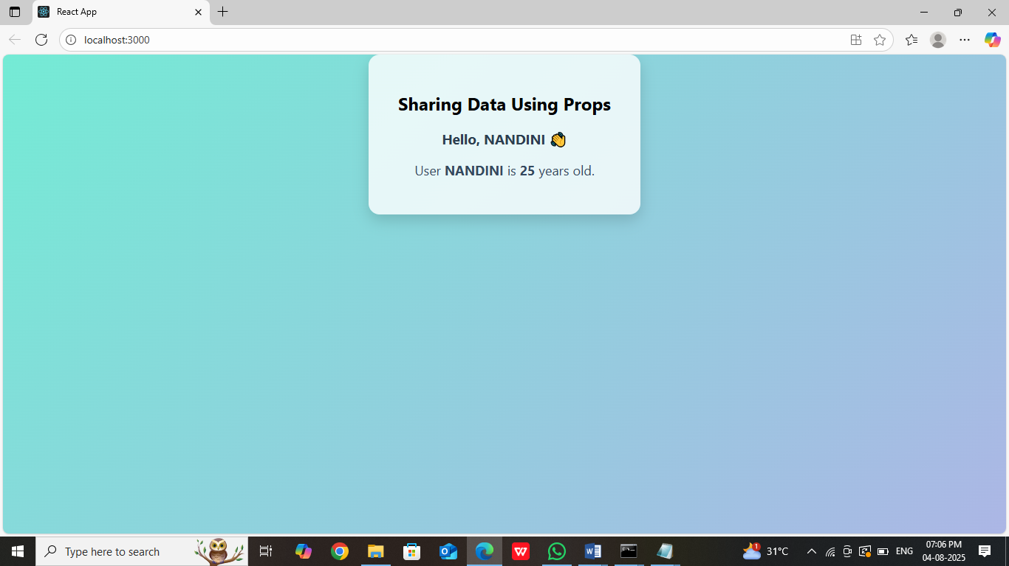

4)
AIM:
write a React program to implement the forms in react.
Description:-
This React form allows the user to input their name, email, and a message. The form uses useState to manage input values (controlled components). When submitted, it displays the data in an alert and resets the form.
Program code :-
📄 App.js

import React, { useState } from 'react';
import './App.css';
function App() {
const [formData, setFormData] = useState({
name: '',
email: '',
message: ''
});
const handleChange = (e) => {
const { name, value } = e.target;
setFormData(prevState => ({
...prevState,
[name]: value
}));
};
const handleSubmit = (e) => {
e.preventDefault();
alert(`Form submitted:\nName: ${formData.name}\nEmail: ${formData.email}\nMessage: ${formData.message}`);
setFormData({ name: '', email: '', message: '' }); // Reset form
};

return (
<div className="form-container">
<h2>Contact Form</h2>
<form onSubmit={handleSubmit}>
<label>Name:</label>
<input
type="text"
name="name"
value={formData.name}
onChange={handleChange}
required
/>
<label>Email:</label>
<input
type="email"
name="email"
value={formData.email}
onChange={handleChange}
required
/>

<label>Message:</label>
<textarea
name="message"
value={formData.message}
onChange={handleChange}
required
></textarea>
<button type="submit">Submit</button>
</form>
</div>
);
}
export default App;

🎨 App.css
body {
margin: 0;
padding: 0;
font-family: Arial, sans-serif;
background: linear-gradient(to right, #fbc2eb, #a6c1ee);
height: 100vh;
}

.form-container {
background-color: #ffffffcc;
padding: 30px 40px;
border-radius: 12px;
width: 350px;
margin: 60px auto;
box-shadow: 0 8px 20px rgba(0, 0, 0, 0.2);
}

h2 {
text-align: center;
margin-bottom: 20px;
color: #2c3e50;
}

form {
display: flex;
flex-direction: column;
}

label {
margin: 10px 0 5px;
font-weight: bold;
}

input,
textarea {
padding: 10px;
border: 1px solid #ccc;
border-radius: 8px;
font-size: 16px;
}

button {
margin-top: 20px;
padding: 12px;
font-size: 16px;
border: none;
background-color: #2c3e50;
color: white;
border-radius: 8px;
cursor: pointer;
}

button:hover {
background-color: #34495e;
}

Output:-
